Datastructures in Javascript
What are Datastructures?
They organize data efficiently, so that you can Store, Update, Delete & Find data quickly.
Datatypes vs Datastructure
Datatypes | Datastructure
In Javascript datatypes refers to the type of data a variable can store, Javascript has primitive datatypes and object types | Collection of different data in a container, it can functionalities to manage the data like find, delete, store, update

Datatypes are of two types
- Primitive types : string, number, boolean
- Non-Primitive types (Object types): object, arrays
Datastructure: They maintain the data in a container, Javascript has built-in datastructure which you can use and perform various operations
- Array: collection of values of same/different types
- Object: it will have properties and functions
- Set: A type of array that can store only unique elements, it doesn’t allow duplicates
- Map: A collection that maintain the data in key & value pairs, ex: maintain database details {username : admin, password : admin123}
Datastructure normally comes with two types
- Linear datastructure: arrays, linked list, stack, queue
- Non-Linear datastructure: trees, graphs
Algorithms: These are step by step instructions written in a human understandable language before writing the actual code, then you can implement them in different languages like Java, Javascript, C, C++
Advantage of using algorithms is
It tells you the time complexity & space complexity of the programs
Time complexity & Space complexity
Time complexity
How much time an algorithm takes to complete the task when the input grows.
Space complexity
How much memory space the algorithm needs to run as the input grows.
Built-in datastructure in Javascript
- Set
- Map
- Arrays
Node.js: It is a runtime environment to run the Javascript without browser
Nodemon: It is a library that can reload your JS application when you make changes in the code
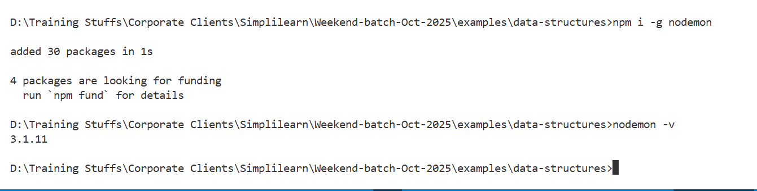

Set: It is a built-in datastructure available in Javascript that maintains only unique elements, it provides methods to manage the elements in the set
Built in methods of Set
- add() : It is to add an element you pass to the Set
- delete() : It removes an element you pass from the Set
- clear(): It removes all the elements
- has(): It checks if the element is present or not in the Set
- size: It is property to check the size of the Set, how many elements are present.

How to create Set?
let names = new Set();
names.add(“Lenovo”);
names.add(“Apple”);
names.add(“HP”);
names.add(“Dell”);
names.add(“Apple”); // it doesn’t add Apple because it is already present.
console.log(names.has(“HP”)) ; // true if present else false
names.delete(“Dell”); // deletes the element Dell
set-demo.js
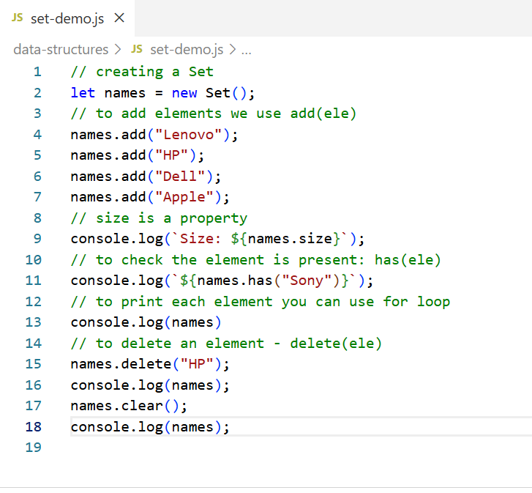
Output:
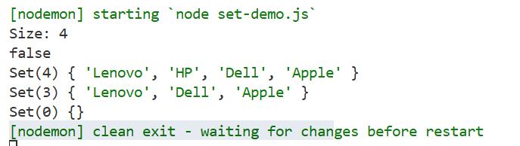
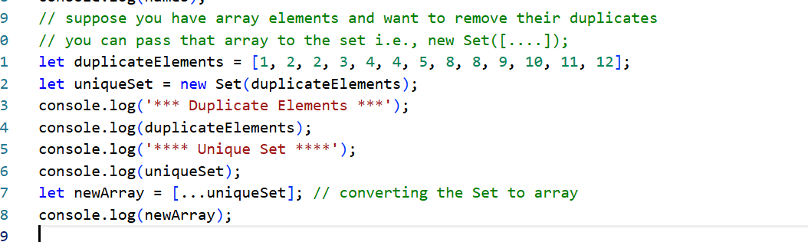

Map:
It is another type of collection that can maintain data in key & value pair, it supports only unique keys however value can be duplicate, below are the methods
- set(key, value) : Add / Update
- get(key): Read
- has(key): Check if the key is present
- delete(key): To delete
- clear(): To delete all
- size: Count
let employeeMap = new Map();
employeeMap.set(1, { id: 1, name : “Alex” });
employeeMap.set(2, {id : 2, name : “Bruce”});
employeeMap.get(1); // returns the value associated with the key 1
employeeMap.delete(1); // deletes the key & value
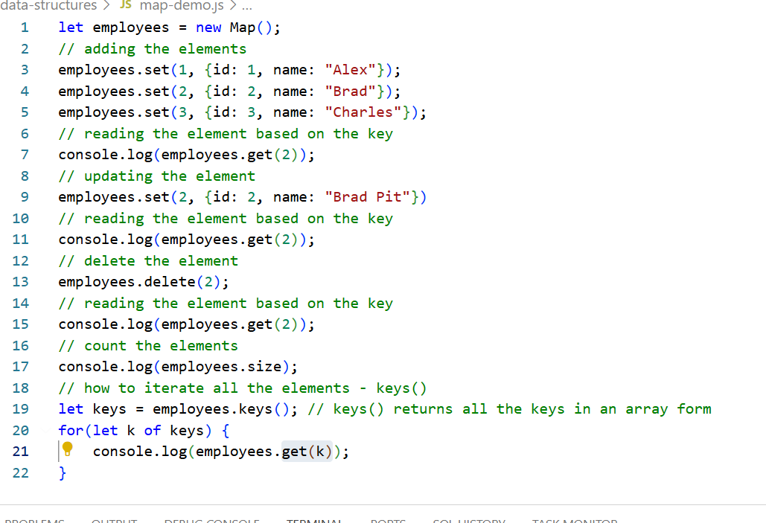
Arrays: In Javascript array can store elements in sequential order, and it has many built in methods
- forEach: to iterate
- map: to transform into another array
- includes: to check if the element is present or not
- push: adds element at the end
- unshift: adds element at the beginning
- pop(): removes from the end
- shift(): removes from the beginning
- slice(): to get a subarray
- filter(): to get an array that matches to the filter/condition
- reduce(): combines into one value - reduces an array into anything like number, object
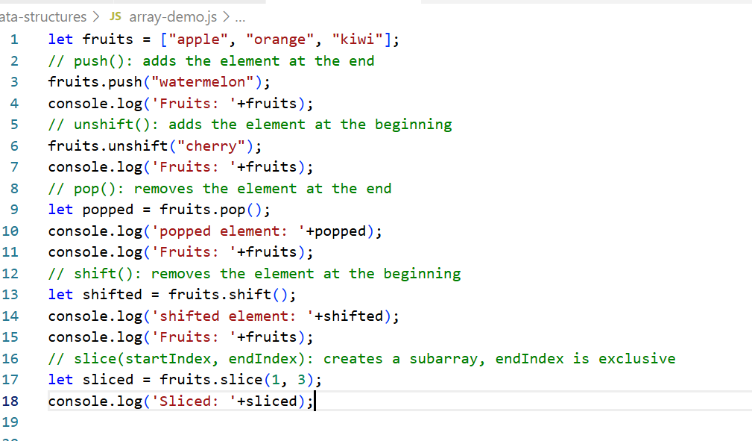
Output:
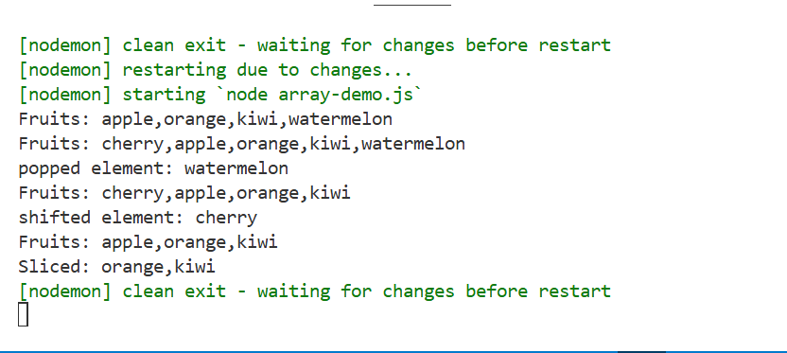

filter(callbackFn): This is used to create a new array by filtering the elements based on the condition
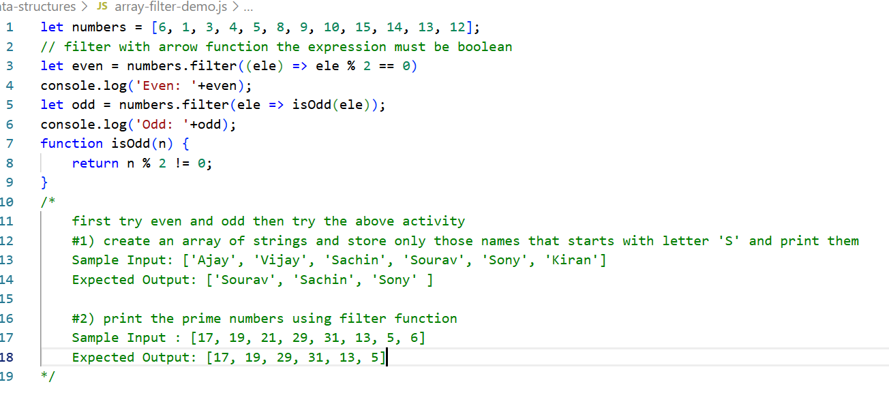
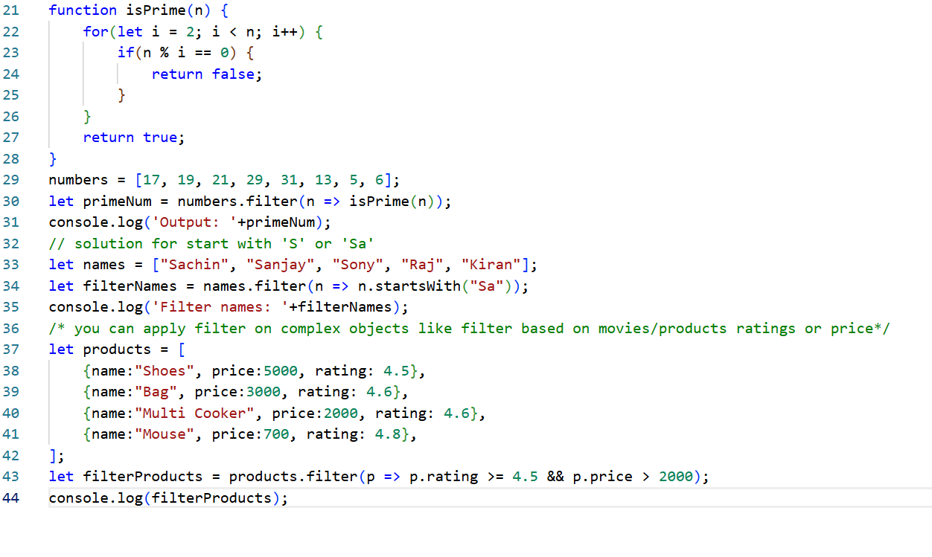
Output:
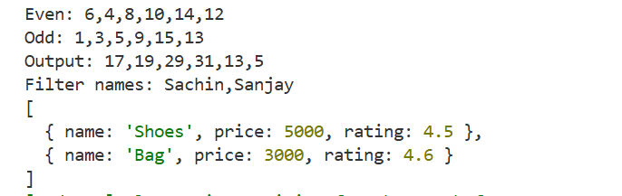
You can also sort the array
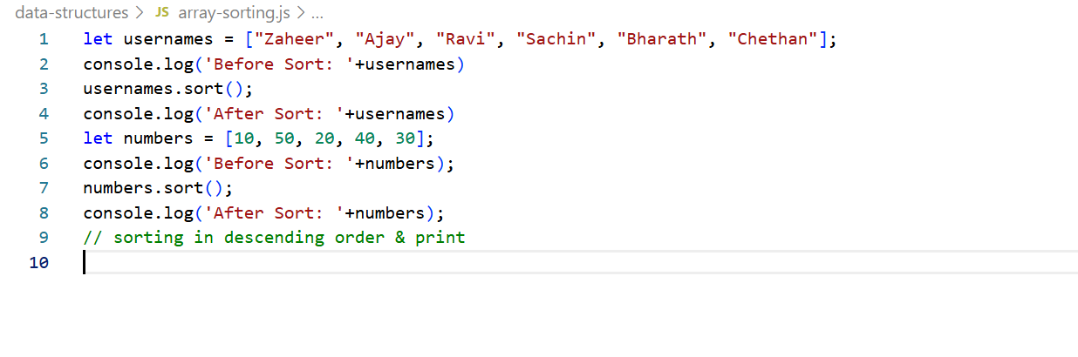
Output:
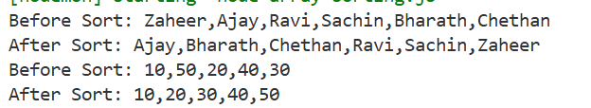
01-02-2026
Arrays reduce method:
Purpose of reduce is to reduce array into single value
Syntax:
arrays.reduce( (accumulator, currentValue) => { /* do something */ }, initialValue);
accumulator: keeps the running result
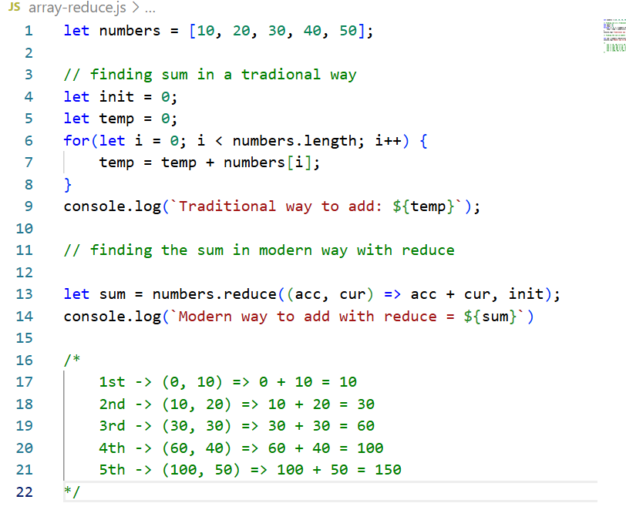
Output:
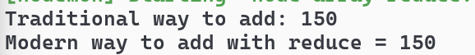
Using reduce for a complex datastructure
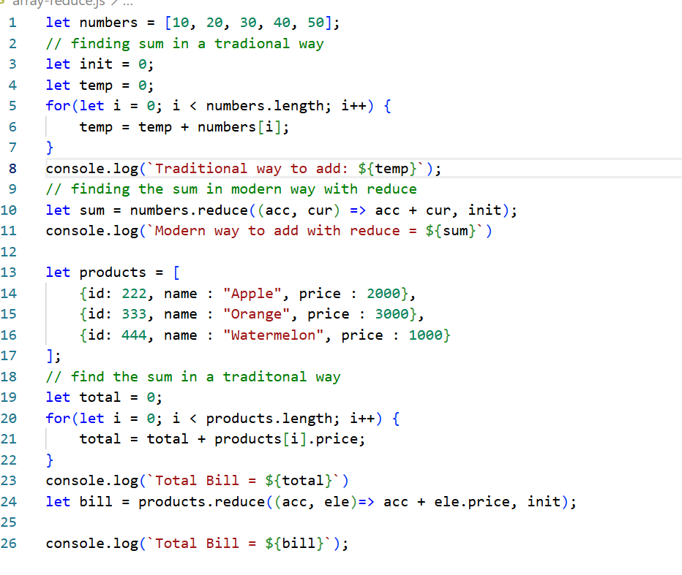
Output:
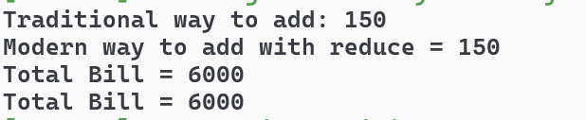
Using the reduce to accumulate complex datastructure
Assume you have a server logs of payments that is SUCCESS or FAIL and you want to display the count of SUCCESS/FAIL.
Adding new properties to the existing object in Javascript with traditional for
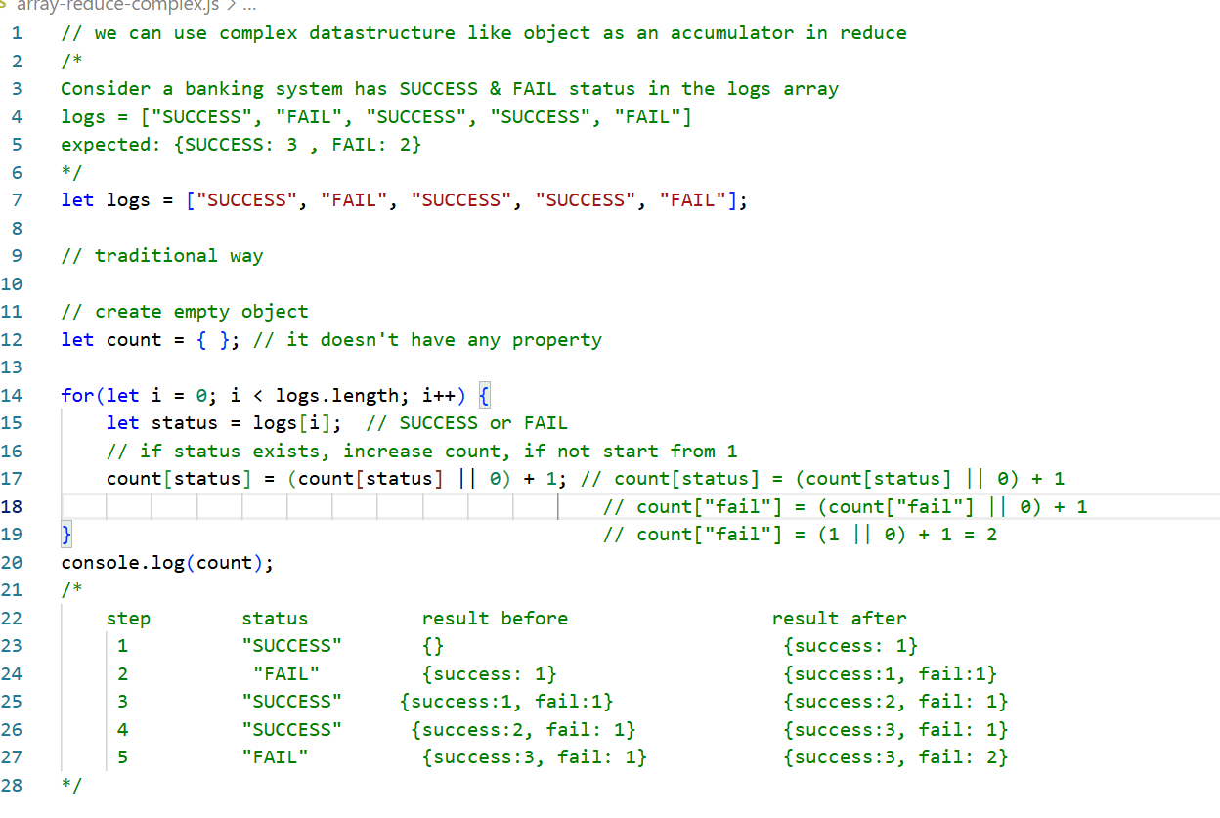
Output:
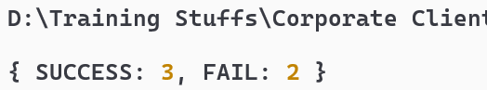

2D arrays
A 2D array is basically an array of arrays
- It stores data in rows & columns instead of a single line.
- Think of it as a table, grid or matrix
Example:
- Seating arrangements in flight or bus or classrooms
[ ] [ ] [ ]
[ ] [X] [ ]
[ ] [ ] [ ]
- Tracking temperature of cities every day
[26, 25, 23]
[30, 31, 29]
[33, 32, 32]
2D array example with tracking temperature & seat booking
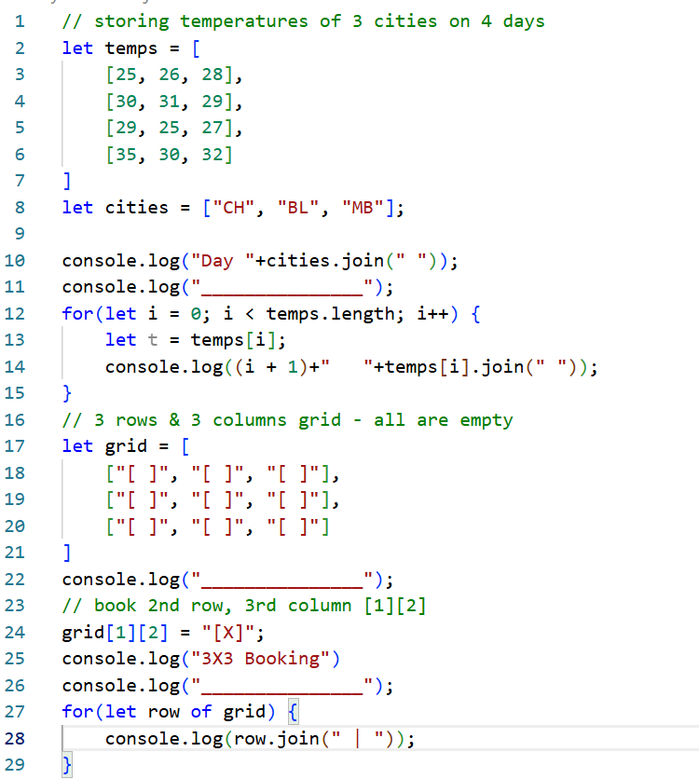
Output:
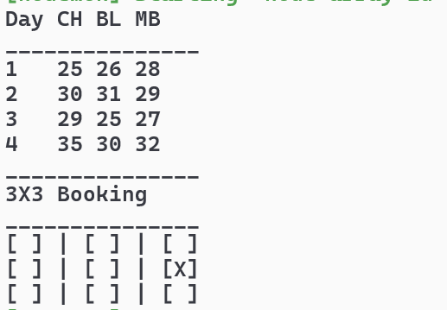
Inserting, Deleting, Traversing over 2D arrays
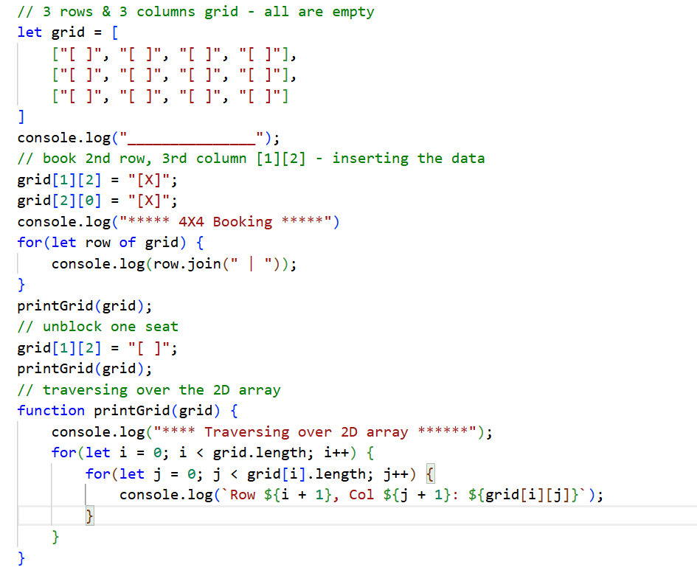
Output:
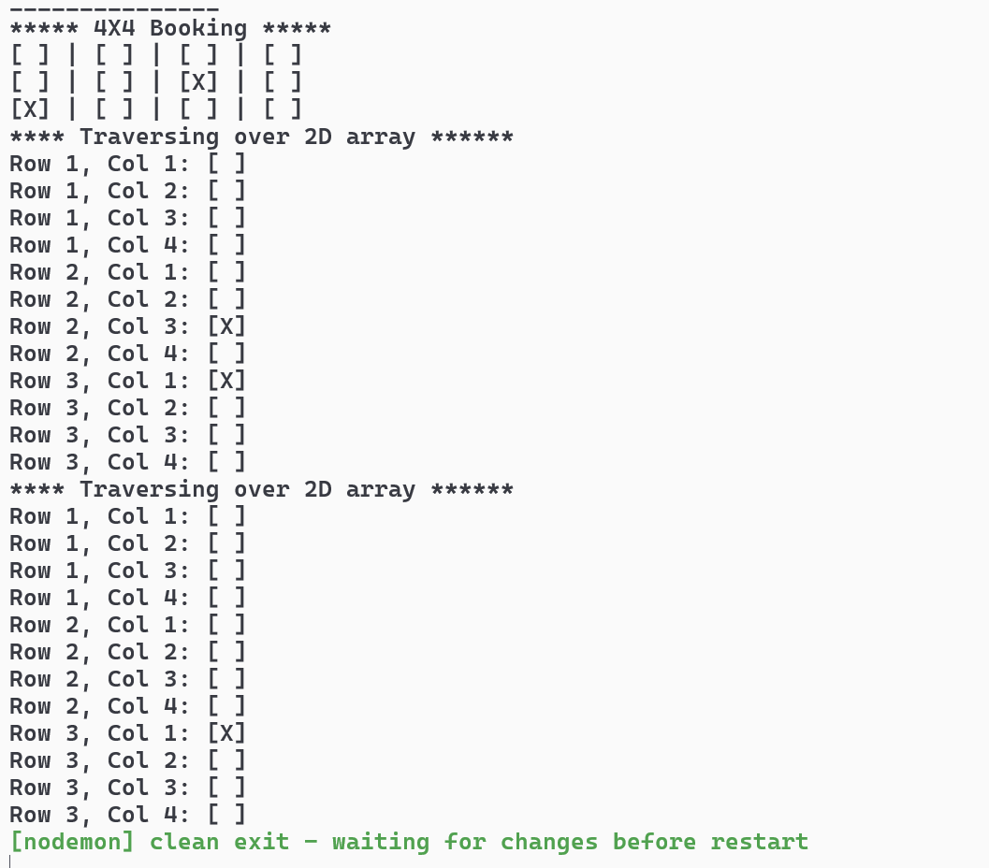
Matrix operations
A matrix is a 2D array of numbers arranged in rows & columns
Activity:
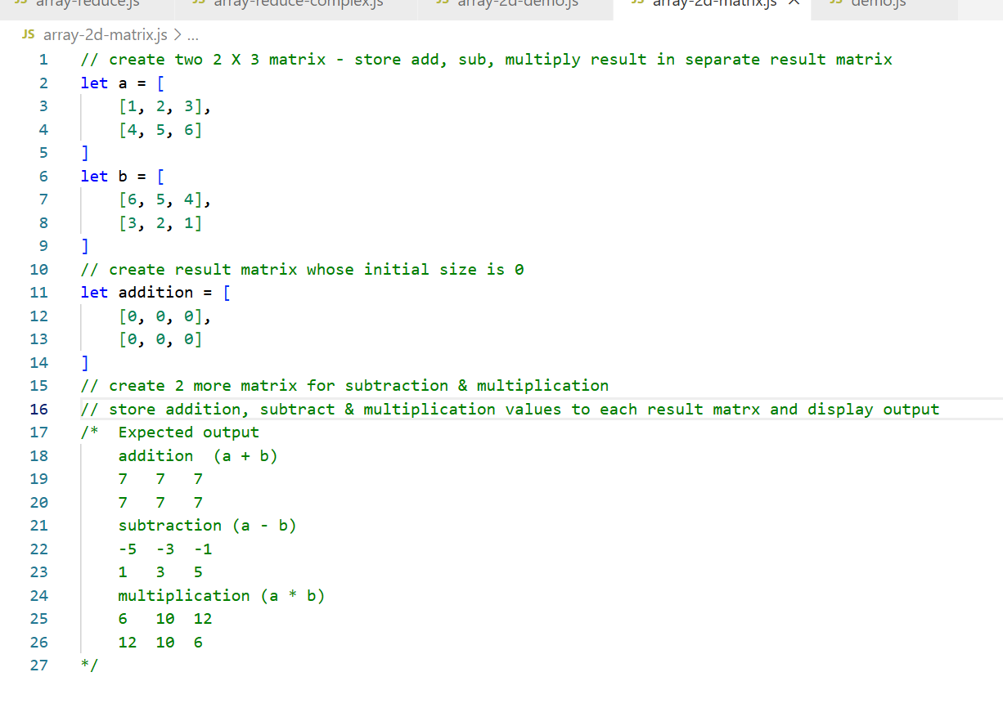
Solution
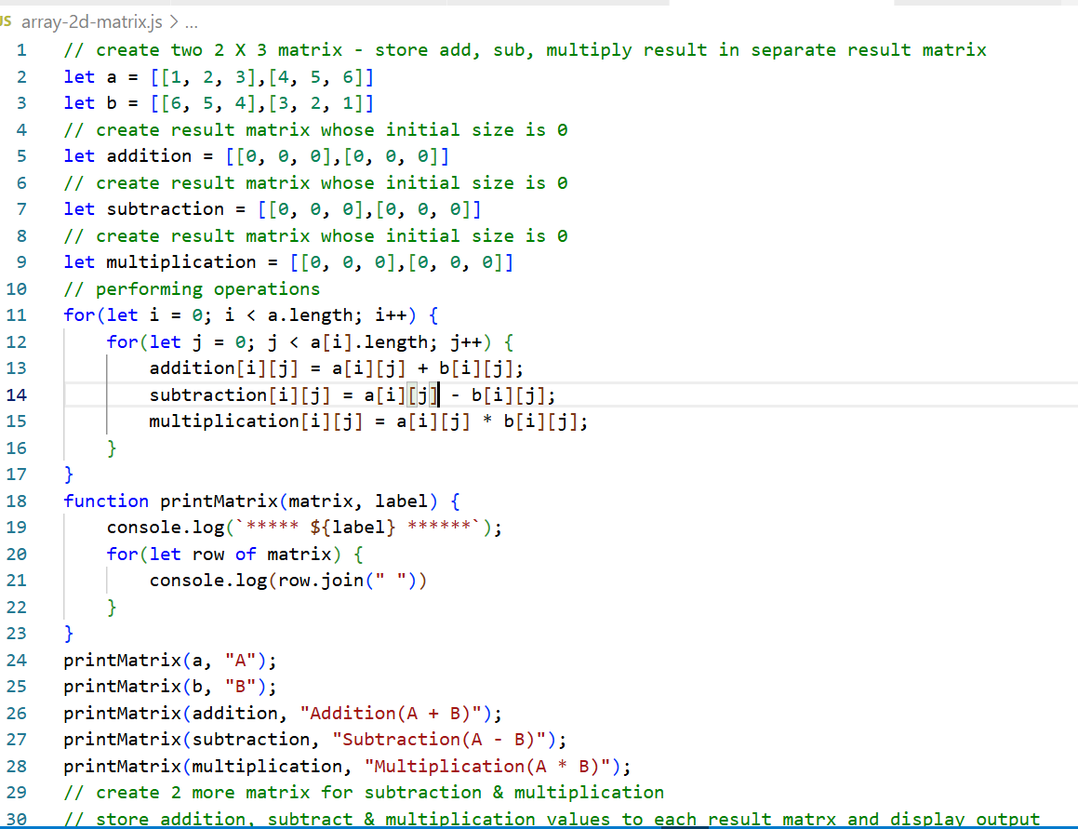
Output:
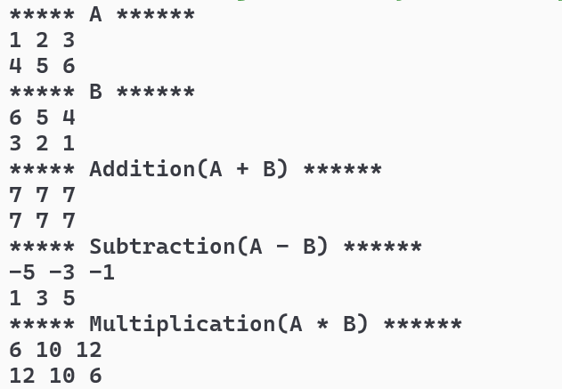

Linked List
A linked list is a linear datastructure like an array, but instead of storing elements in contiguous memory address, each element points to the next element.
Here element is called as node, a node contains two things
- Data - the value
- Pointer / Next - reference to the next node
Why linked list instead of array?
- Dynamic in size - when you add/remove elements memory will increase/decrease
- Efficient deletion / insertion - especially in the middle of the list
Simple linked list that has a single node?
class Node {
constructor(data) {
this.data = data;
this.next = null;
}
}
Single node example
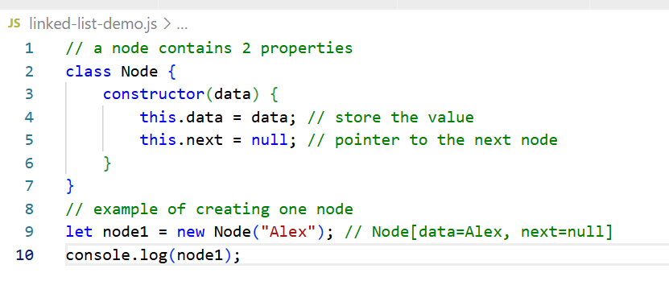
Output:
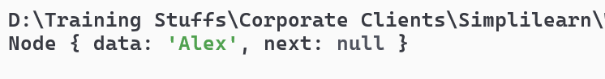

SinglyLinkedList
Add & Display the data
linked-list-demo.js
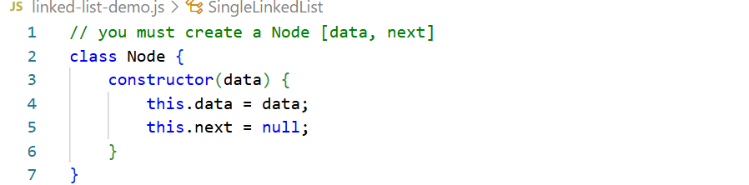
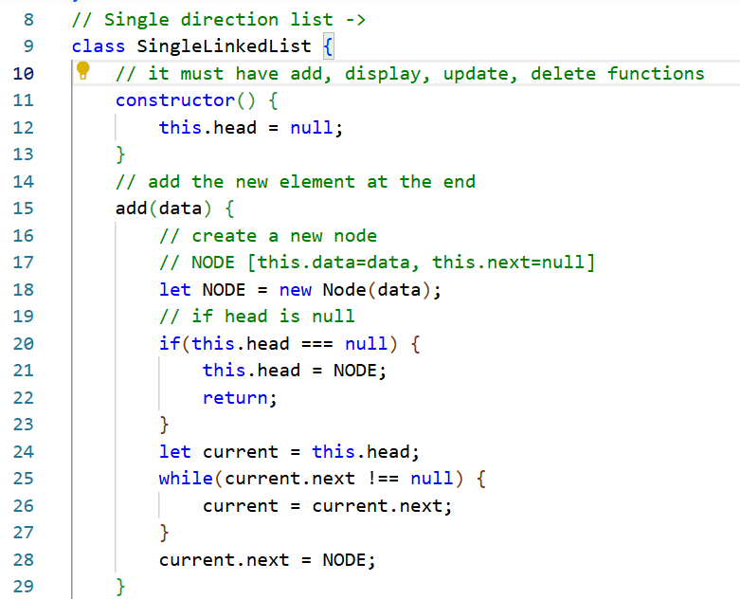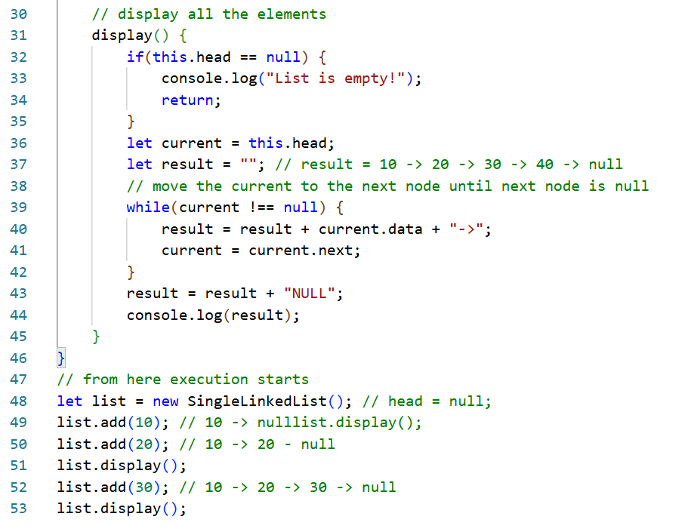
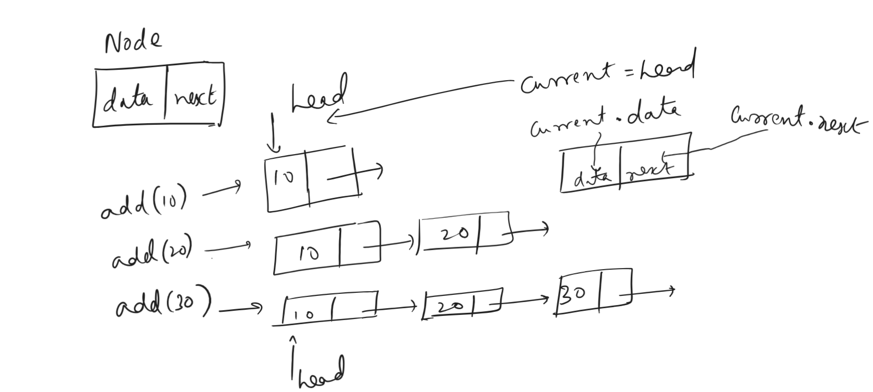
Output:
We must able to do other operations like update & delete
Update operation
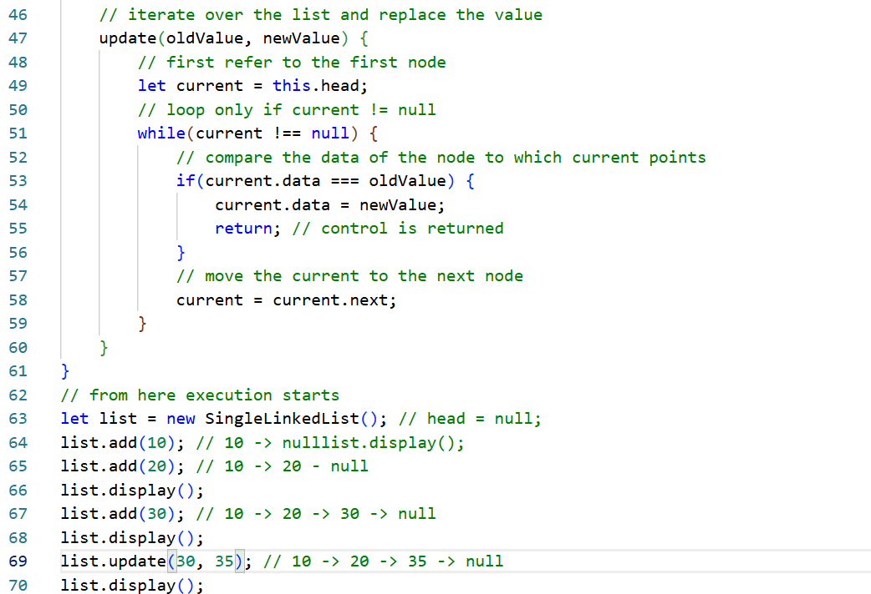
Output:

Activity
Create delete(data) function in the SingleLinkedList which removes the element in the LinkedList
Suppose the list is empty, if you invoke display -> it must print list is empty
Suppose you try to delete or update the data and if data is not present -> it must print the data is not present
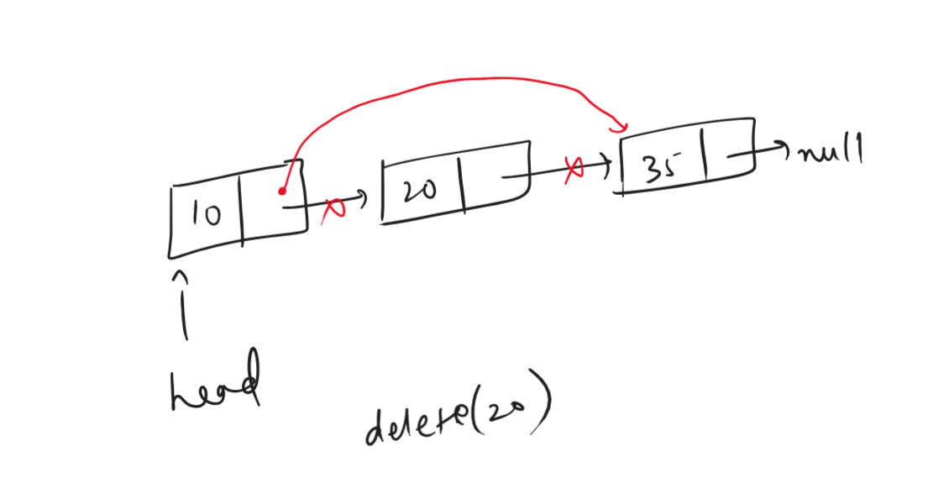

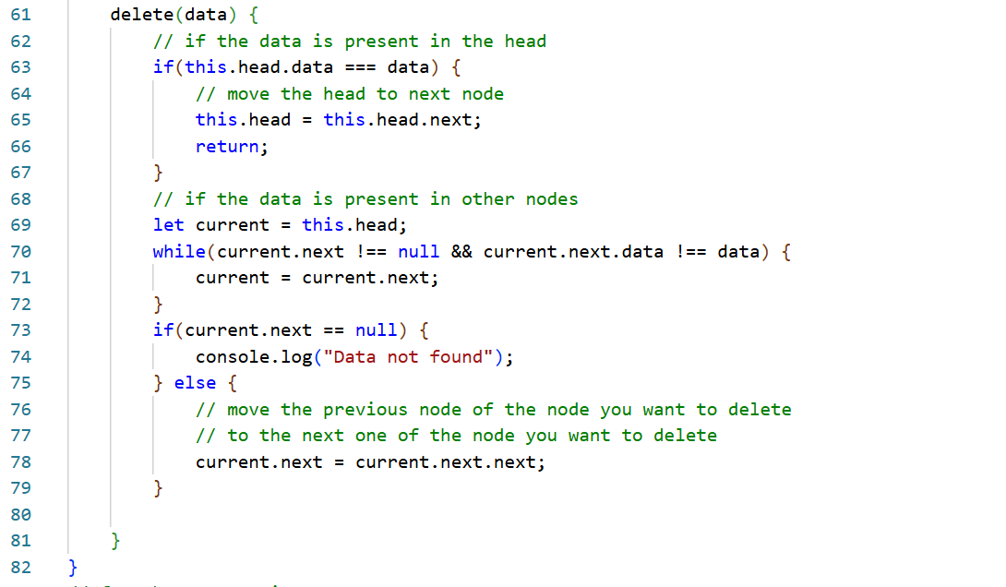
Doubly linked list
Each node knows next node & previous node, can move forward & backward
Ex: Browser history back, forward button, page1 <-->page2<->page3
Add, Display Forward & Display Backward
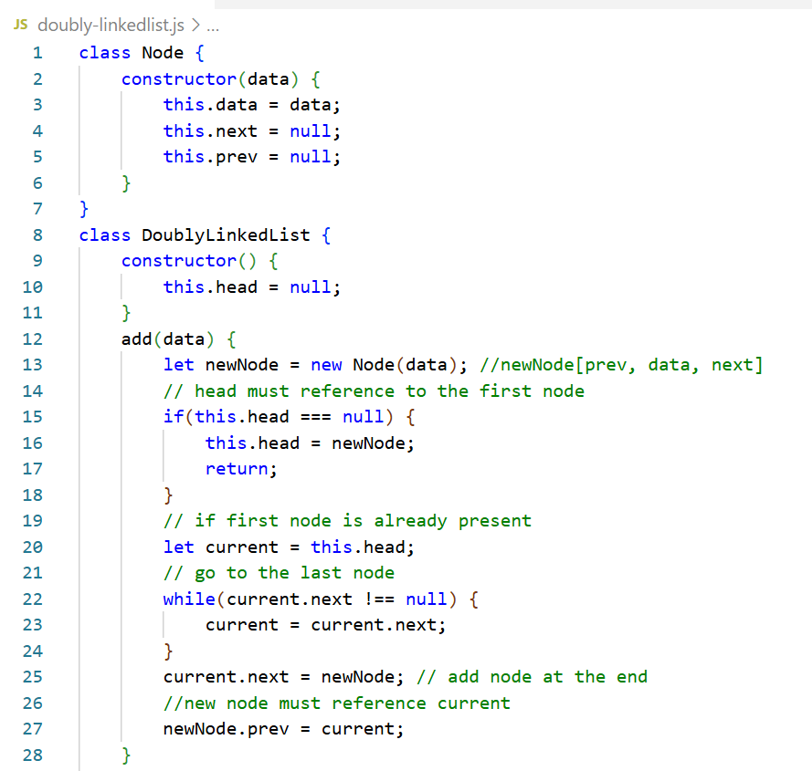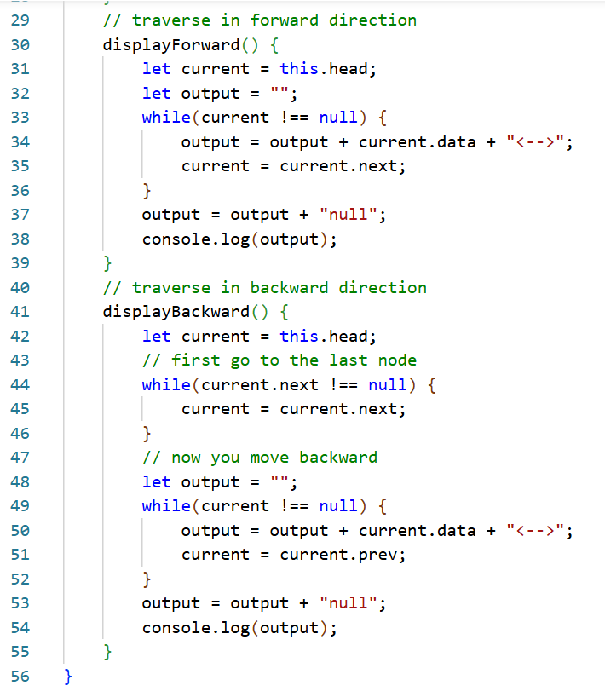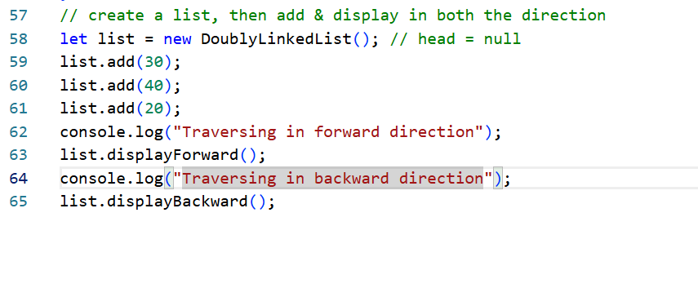
Output:
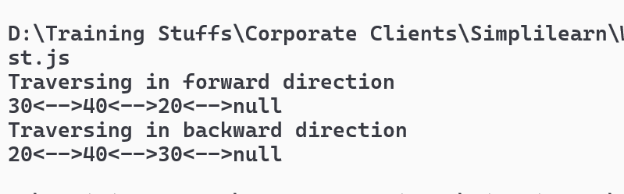

Activity
Currently, the DoublyLinkedList has a head pointer that points to the first node. Create another pointer called tail that moves along with the newly added nodes. Rewrite displayBackward() so that it directly starts from the tail and moves backward using the prev pointer. Implement removeFirst() such that the first node is removed and head points to the next node. Similarly, implement removeLast() so that the last node is removed and tail moves backward to point to the previous node of the deleted node.
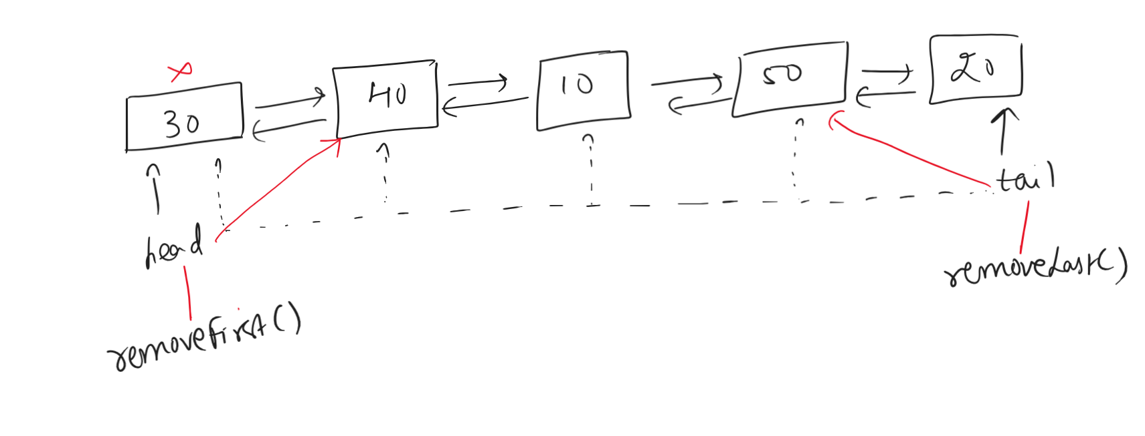
Using tail avoids pointer to move from the beginning to the end and then traversing form the end
tail moves every time new node is created
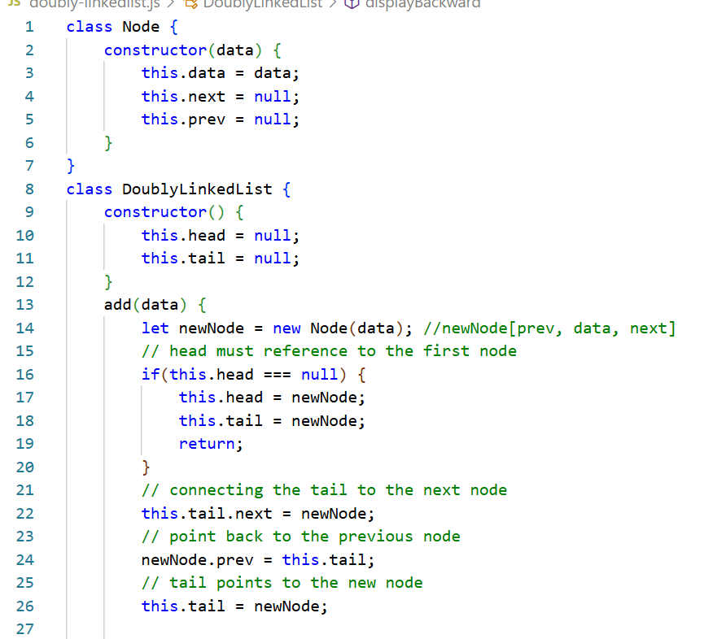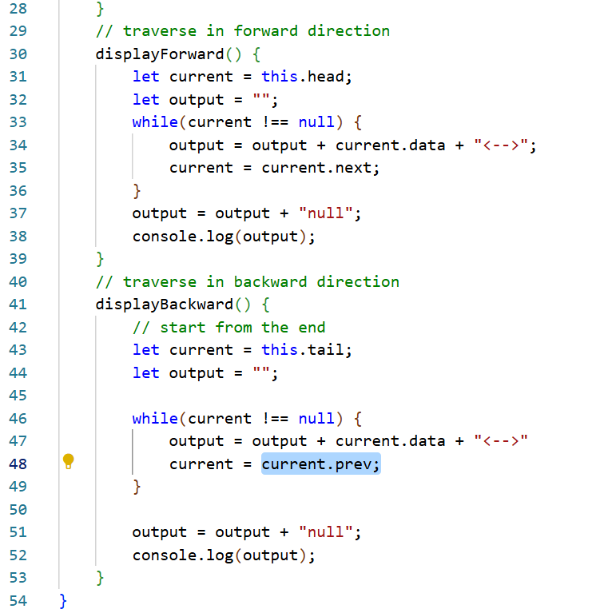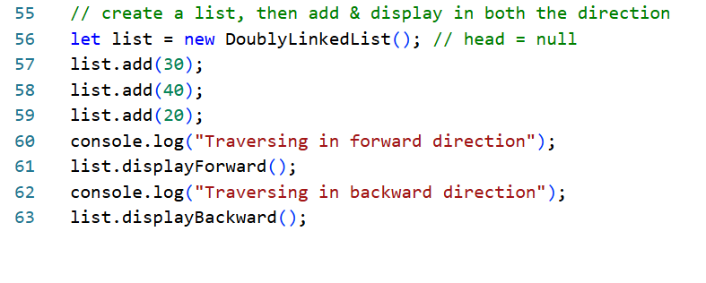
Reversing the doubly linked list
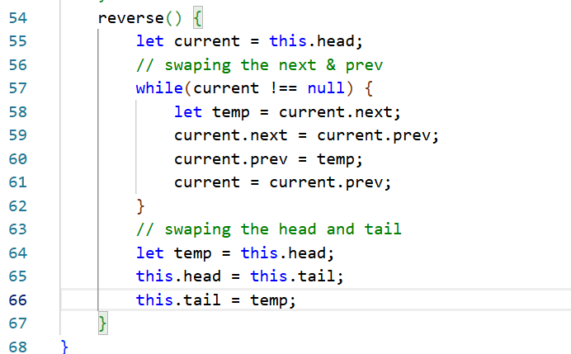
output:
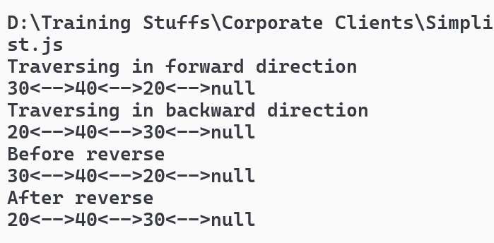
Circular linked list
In a circular linked list, the last node points back to the first node, there wouldn’t be null at the end.
Normal linked list
10 -> 20 -> 30 -> null
Circular linked list
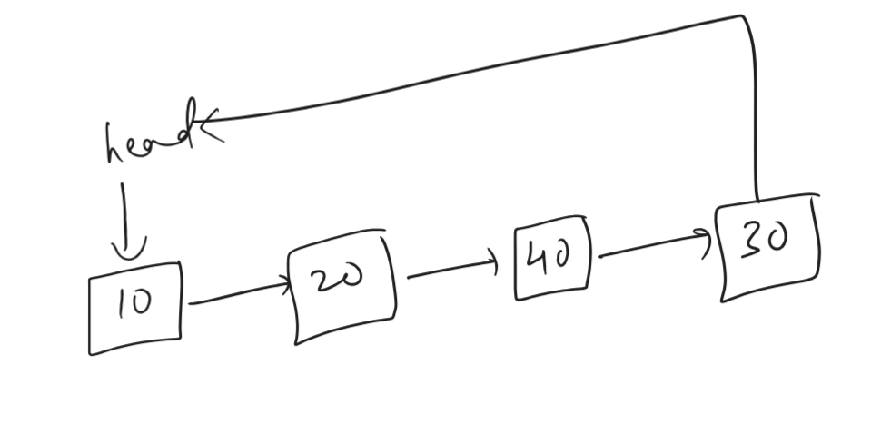
Adding: new node must point back to the first node or head
this.head = newNode;
newNode.next = this.head;
Displaying: We can’t use while(current !== null) because null never comes, we use do { } while(current !== head)

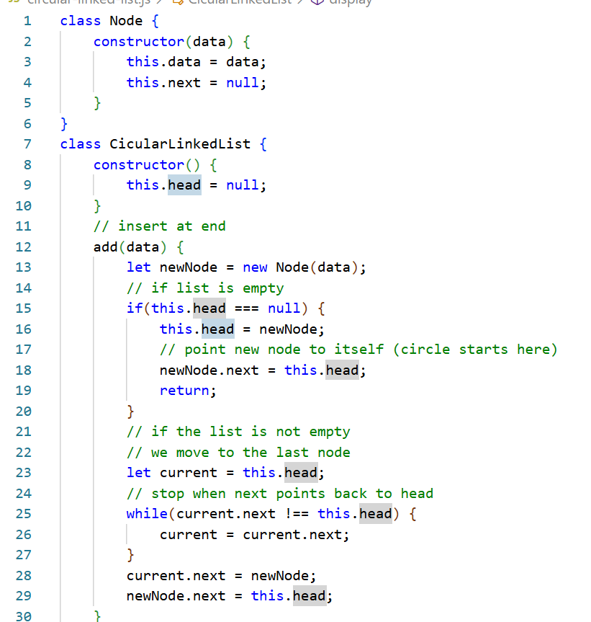
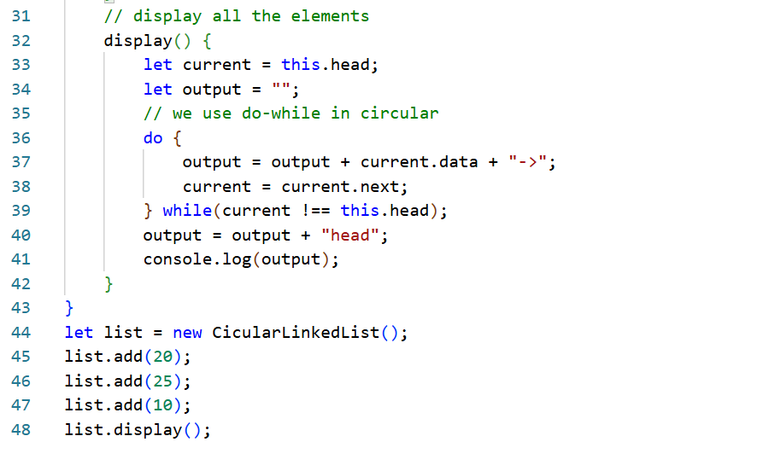
Output:
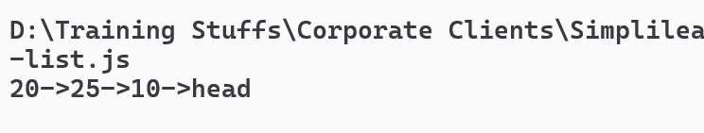
Activity:
Perform update & delete on a circular linked list, so that you will only change the links between the node you deleted and their previous & next node when the node is deleted, the update must only update the existing value with the new value.
14-02-2026
Stack & Queue
A stack follows Last In, First Out order
Ex: Text editors, every action -> push into stack; undo -> pop the last action
Ex: Loading dependent resources like A -> B -> C -> D
Some of the operations in stacks are:
- push - to add the elements at the top
- pop - to remove the element added at the last
- peek - to read the top most element
- display - to display all the stack elements
Queue
First element added is the first removed, it is used wherever things must be processed in the same order they arrive
Ex: ticket counters, call centres, print jobs
Some of the operations in queue are:
- enqueue - to add the element at the end
- dequeue - to remove the element from the front
- display - to display all the elements
- peek - to read the element from the front.
Stack program
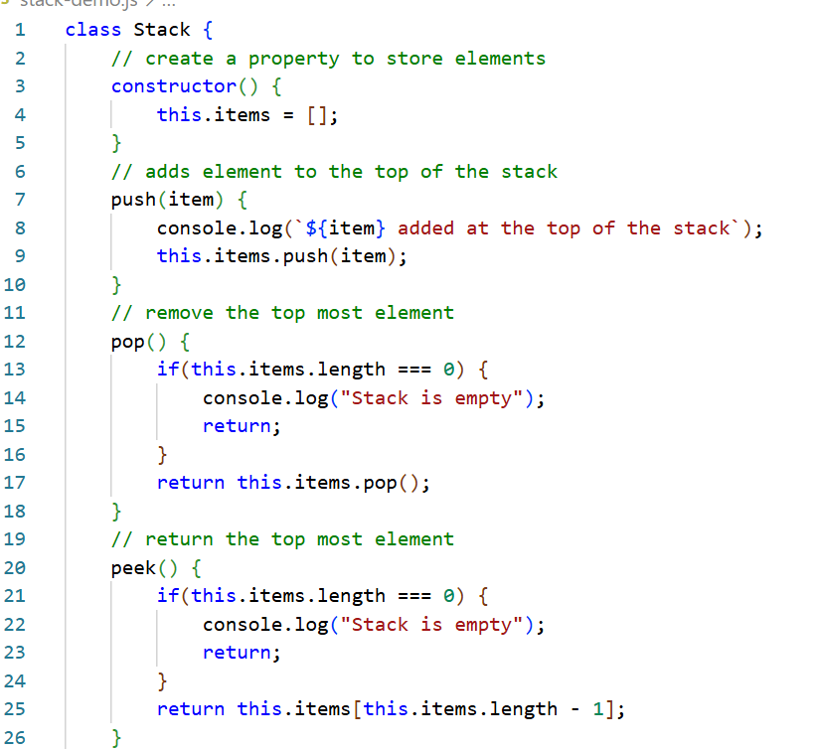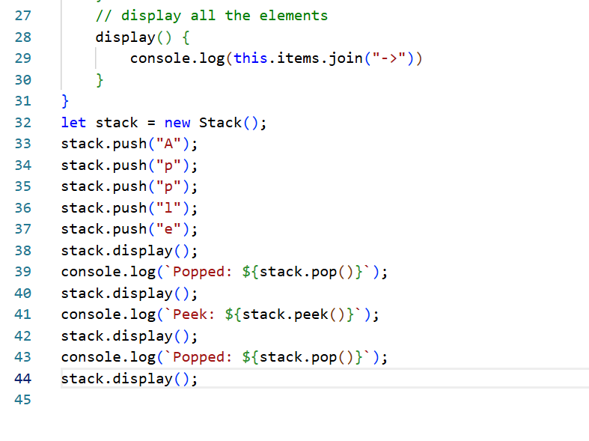
Output:
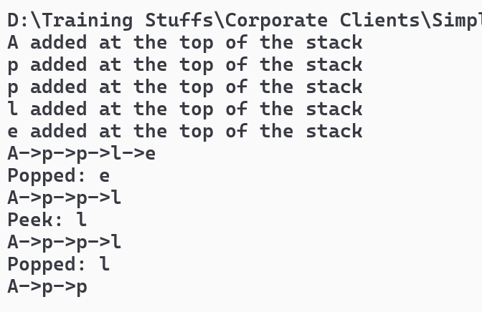
Queue Example
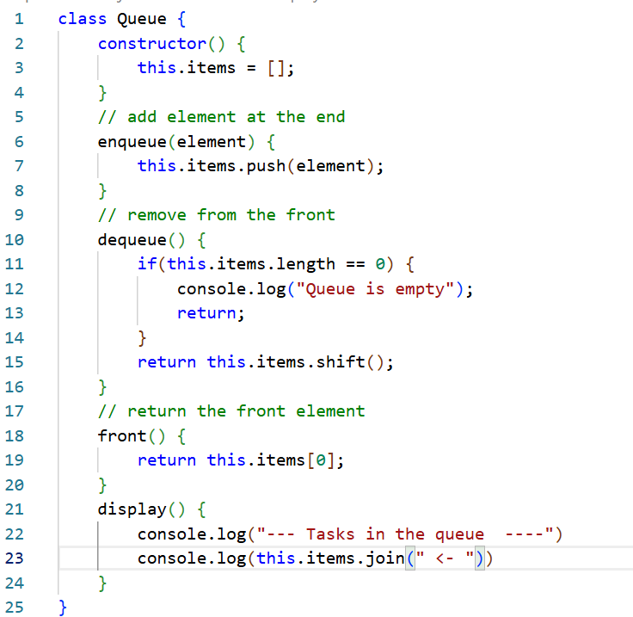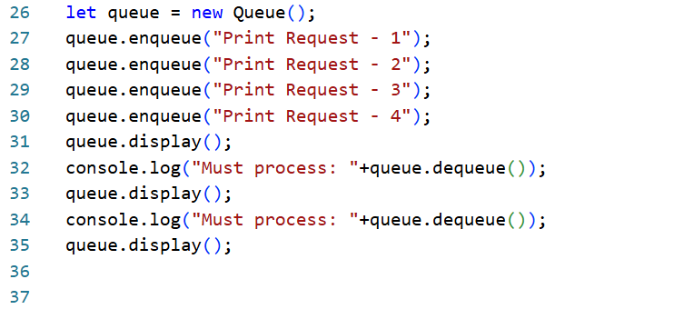
Output:
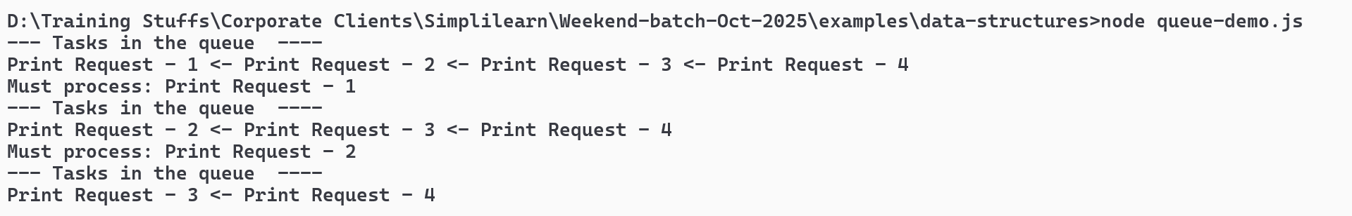

Activity Using Stack
Determine whether a string of brackets is balanced or not balanced, every opening brackets must have corresponding closing brackets and they must be closed in the correct order, don’t use counters to validate the brackets, your program should print valid if the string has balanced bracket, else invalid, create isValidBracket(input) method that returns boolean value
Sample inputs & outputs
Input | Output | Explanation
({[]}) | Valid | All brackets are correctly nested
(()) | Valid | All brackets are correctly nested
([)] | Invalid | Closing ) mismatches opening [
((( | Invalid | Extra opening brackets, no closing
()) | Invalid | Extra closing bracket, no matching opening

Non linear datastructure
Linear - Everything is in a straight line
Example: standing in a queue, each person has one before and after
Non-Linear - Things are not in a straight line, they are connected like a tree or web
Example: Family tree
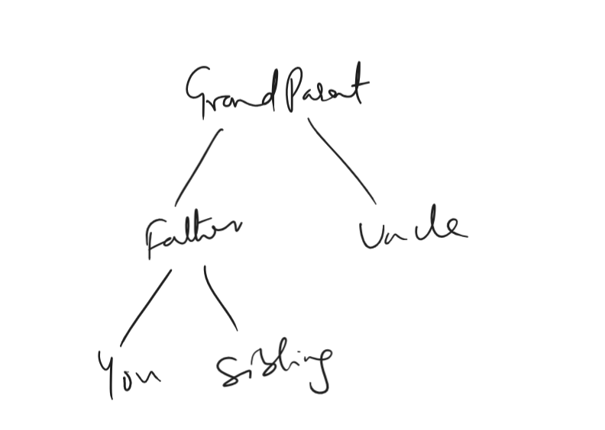
This is called as tree datastructure
Example: Graph, think of cities connected by roads
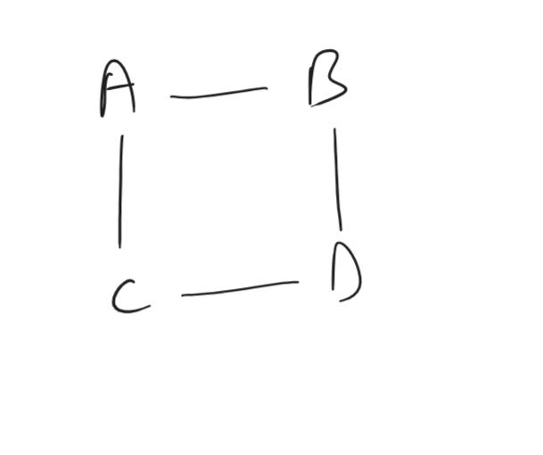
This is called as Graph data structure.
Here data connected like a tree or a web, not in a straight line.
Why non-linear data structure
- When one thing connects to many things, principal -> many teachers, teacher -> many students, if we use straight line, then it will be confusing, hence we use tree structure, so that it is easy to organize, you can find the data easily
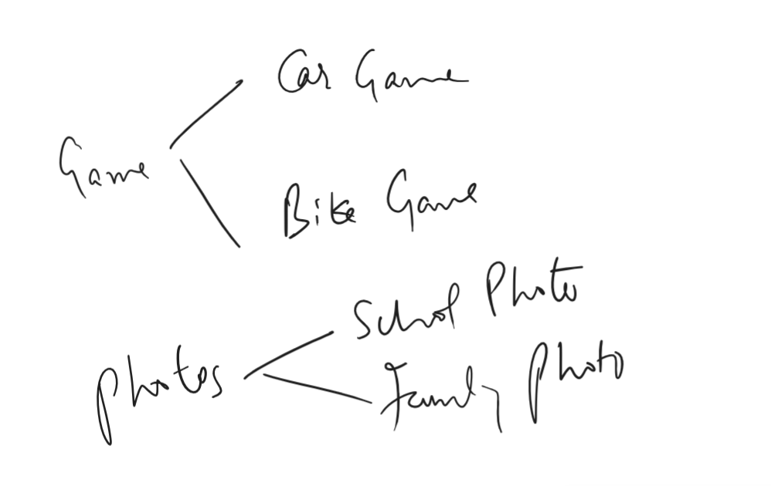
If you organize these above data in a single line, it will be hard to find, hence you go with hierarchical structure i.e., tree structure
- Maps & Roads, your home connects to School, Hospital, Shop
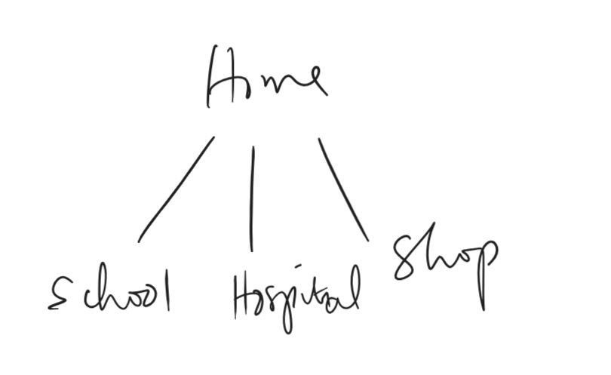
Helps to find shortest path, Google maps use graph, social media friends like whatsapp/facebook, you connect to friend1, friend2, friend3, they connect to others
When to use non-linear data structure
- one thing connects to many things
- data has branches
- data has network
- need fast searching
Linear & Non-linear
Linear | Non-Linear
Engine -> Coach -> Coach -> Coach | Branch -> Branch -> Branch
Family tree, school system, computer folders (these are all tree)
Google maps, social media friends (Graph structure)

Binary tree
Each node has maximum 2 children
- left child
- right child
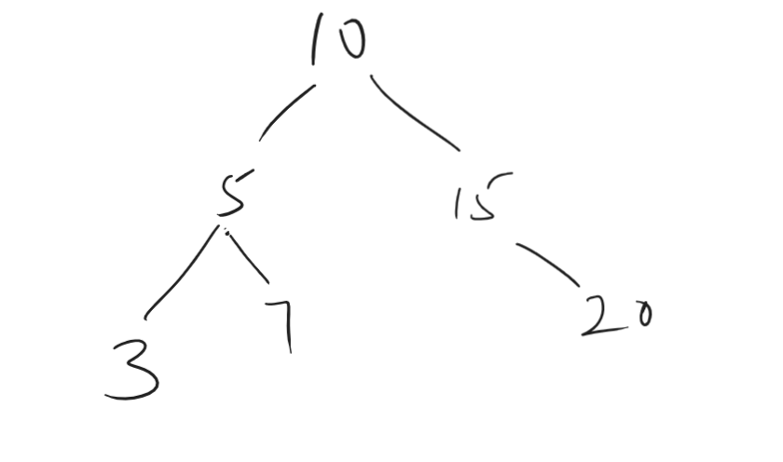
Binary Tree
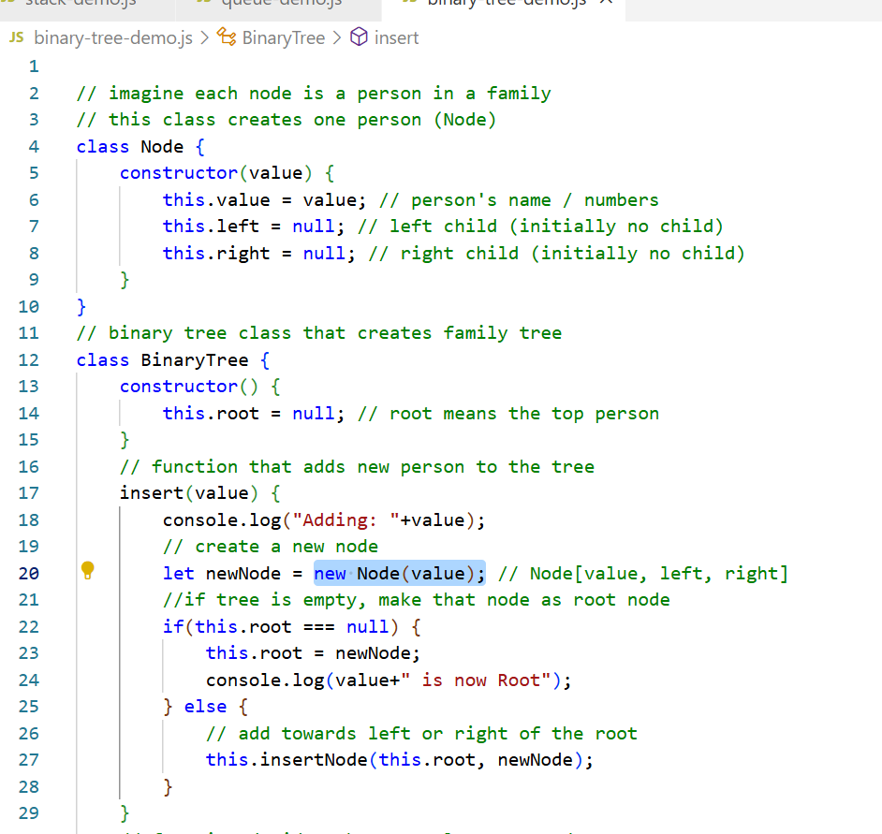
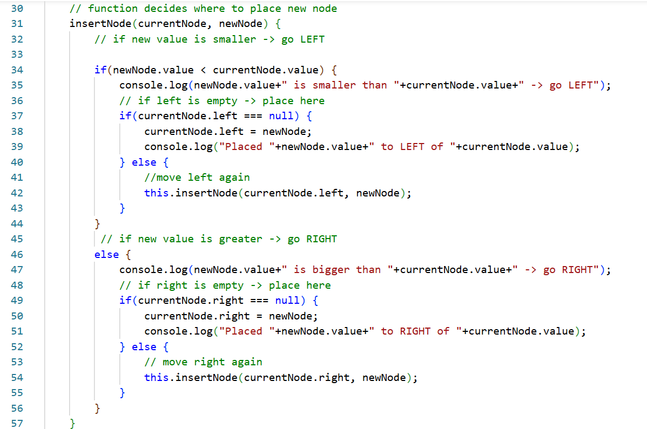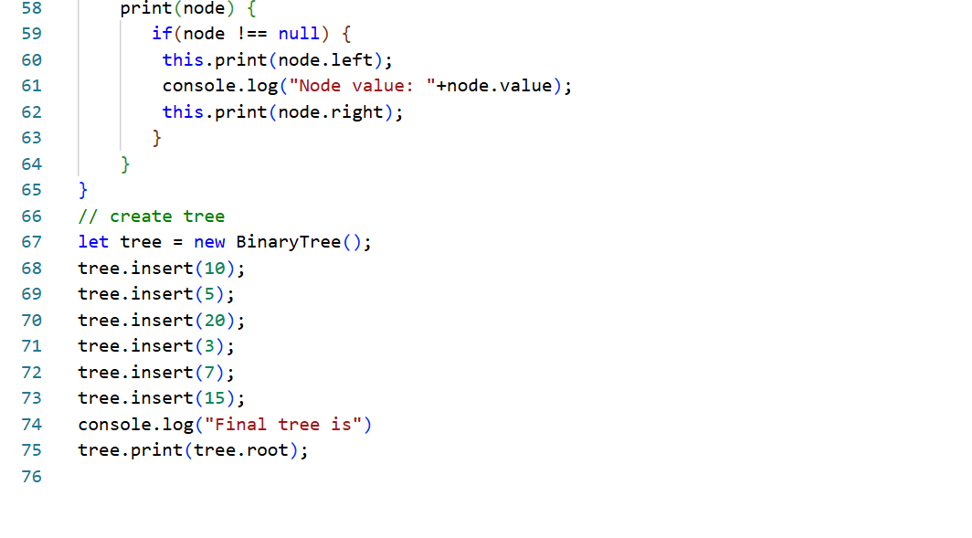
Output:
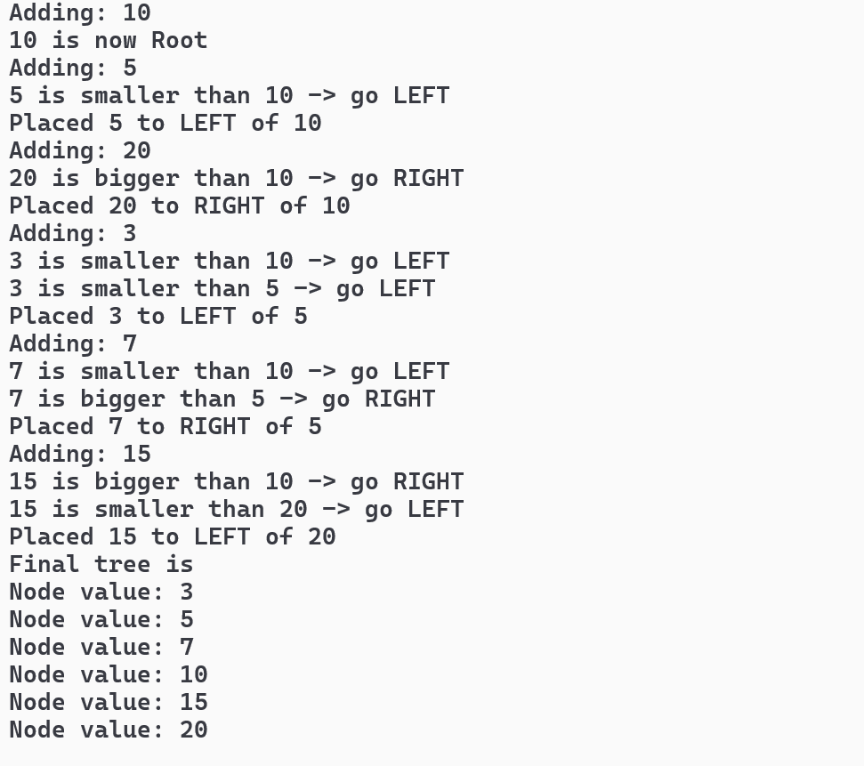
15/02/2025

Graph:
One person connected to many friends
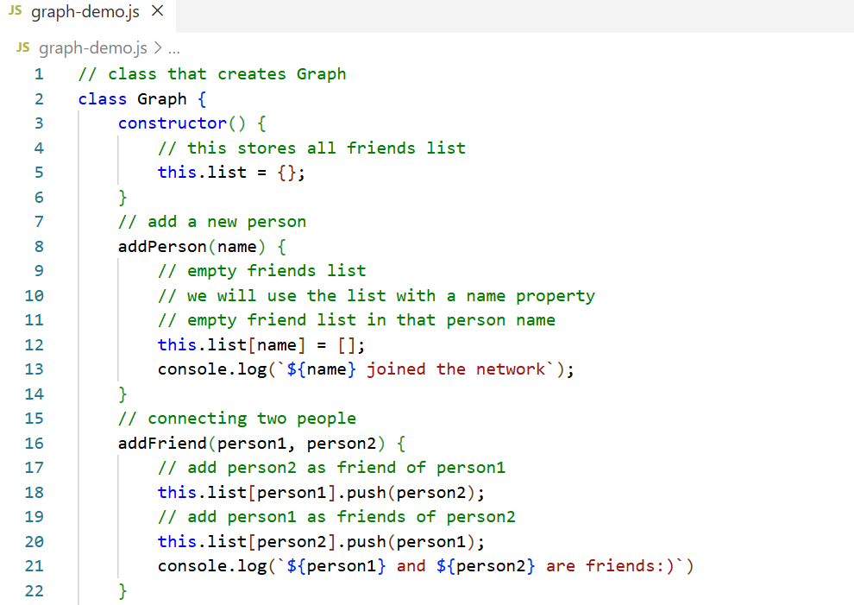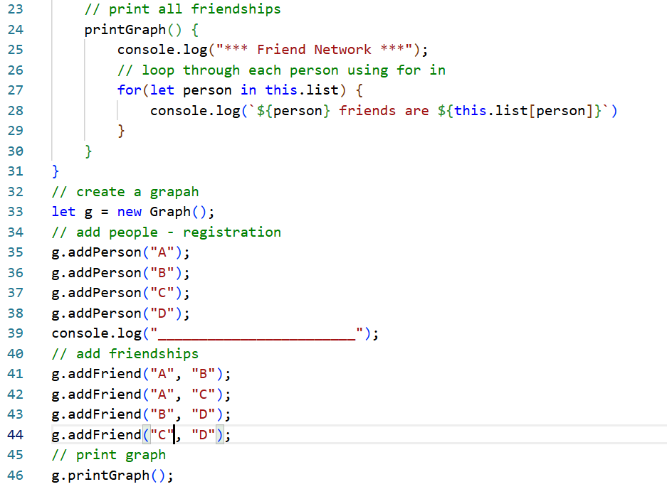
Output:
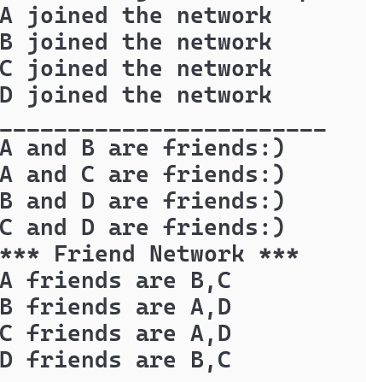

Sorting
You can write programs to sort the data, types of sorting
- Bubble sort
- Selection sort
- Insertion sort
- Merge sort
Bubble sort: Here you will compare two numbers and swap them if they are in wrong order
Selection sort: You fill find the smallest number & put in the correct place
Insertion sort: Compare and insert in the correct position
Merge sort: Divide and conquer(Sort while joining)

You can choose sorting based on the factors
- Data size (small vs large)
- Data condition (already sorted or random)
- Memory available
- Number of swaps allowed
Bubble sort
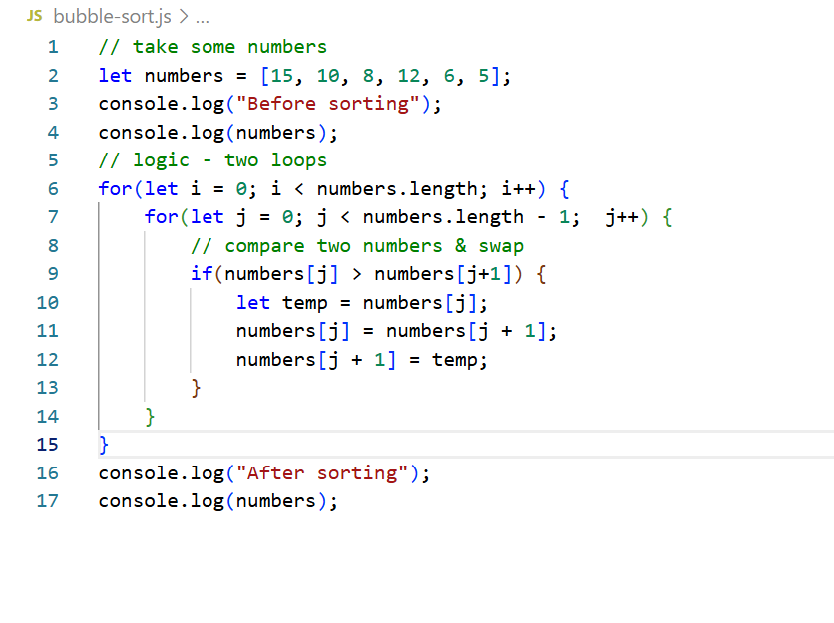
Output:
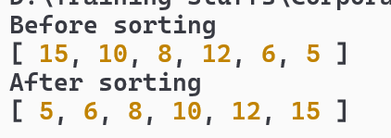
Project work
You must create Nodes one for LinkedList & another for BinaryTree, a Bank class that will perform following operations like addAccount(), checkBalance(), transfer()
Using LinkedList & BinaryTree you must able to manage the account.
Activity: Complete other features

